Project Green Synergy
Business development for SMEs and Entrepreneurs
2022-1-CY01-KA220-VET-000087187

Mapping of Current Situation

European Snapshot

This project has been funded with support from the European Commission.
This publication reflects the views only of the author, and the Commission cannot be held responsible
for any use which may be made of the information contained therein.

Table of Contents

Introduction 3

Current Situation of Smes and Entrepreneurs/Sustainable Development in Europe 5
Need for training for a sustainable development 10

Conclusions 15

Introduction

SMEs represent the majority of European enterprises (99.8%) and employment contributors (65%) and account for over 60% of all businesses’ greenhouse gas emissions (GHG emissions). Therefore, SMEs are essential to the success of the European Union’s challenging initiative to shift towards an environmentally friendly and sustainable economy: the European Green Deal. The Green Deal seeks to address the issues of climate change and environmental degradation, decarbonizing the economy and enhancing the efficient use of resources, calling for significant economic and societal transformations that involve all sectors of society. The Green Deal also aims to improve the competitiveness of the European economy and industry in the global market.

In this framework, a growing number of SMEs are starting their transition to sustainability, engaging in transformational processes, and seeing sustainability as a business opportunity. An increasing number of SMEs are focusing on sustainability by investing in sustainable technologies and acquiring the necessary skills and knowledge to transform their operations and maintain competitiveness. Over 50% of SMEs have invested or intend to invest in initiatives aimed at reducing emissions and mitigating the effects of climate change. Furthermore, over two-thirds of SMEs are actively involved in resource efficiency practices, primarily through minimising waste or conserving energy.

Moreover, SMEs can reap the benefits of the EU interconnected green and digital “twin transition”. Digitalization has the potential to increase SMEs productivity and minimise their environmental footprint. While quantifying the aggregate environmental gains of digitalization can be challenging, certain solutions such as ICT tools that reduce the need for travel offer significant co-benefits for the sustainability transition.

However, this transition poses a challenge for SMEs, requiring them to adapt their business models and ways of operating. More than 90% of SME associations have reported that SMEs are facing strong external pressures to achieve climate neutrality. The defining characteristics of SMEs, such as operating in a specific geographic and product niche, having restricted access to resources or and having limited influence on the broader business environment and supply chains, influence the manner and extent to which they engage in the sustainability transition.

It is worth noting that the Russian war of aggression against Ukraine might affect the transition pathway of SMEs via different channels. Rising energy prices change the economic considerations of resource efficiency actions and potentially raise the ambitions of SMEs to become carbon or climate neutral. SMEs in the “energy – renewables” and “aerospace and defence” ecosystems might benefit from increased demand, while SMEs in the ‘energy-intensive industries’ ecosystem will face rising production costs.

In 2019, the “energy-intensive industries”, “agri-food”, and “mobility, transport and automotive” ecosystems generated the most GHG emissions in the EU, making them prime targets for emission reduction efforts. Additionally, some of the most emission-intensive ecosystems, such as “agri-food” and “mobility, transport and automotive”, face unique challenges in successfully transitioning to sustainability.

For promoting the sustainability transition of SMEs and facing all those challenges, the European Commission has implemented several policy initiatives that will be explained in detail in the following paragraph, like the EU Emissions trading System, the Carbon Border Adjustment Mechanism, Circular Economy Action Plan and the SME strategy. Regulatory framework simplification and measures supporting research and development, such as the SME Test can also positively affect the economic and legal environment for SMEs’ sustainability transition. The SME Test examines how potential EU legislative proposals could affect Enterprises. The "think small" philosophy is put into practise through the SME Test, which includes preliminary evaluation of firms that may be impacted, engagement with SMEs and SME representative organisations, measurement of the impact on SMEs, and application of mitigation measures. Furthermore, the Commission, in partnership with the EIB Group and National Promotional Banks, offers various financial instruments to support SMEs’ access to finance, including measures addressing sustainability transition.

Current Situation of Smes and Entrepreneurs/Sustainable Development in Europe

By 2050, global consumption of resources such as biomass, fossil fuels, metals, and minerals are expected to double, leading to annual waste generation increasing by 70%. As a result, the European Green Deal has launched a strategy to create a climate-neutral, resource-efficient, and competitive economy to create a carbon-neutral economy by 2050. This transition provides new business opportunities, with circular economy principles potentially increasing EU GDP by 0.5% and creating around 700,000 new jobs by 2030. Moreover, innovative models powered by digital technologies, such as the internet of things, big data, blockchain, and artificial intelligence, will accelerate circularity, dematerialization, and reduce Europe’s dependence on primary materials.

To implement the Green Deal and make their objectives possible, several initiatives and programmes are put into action. The majority of these are ambitious and comprehensive and deeply affect SMEs. The following EU climate policies and components of the European Green Deal are particularly noteworthy due to their effects on SMEs:

- The EU Emissions Trading System (EU ETS), which was among the first emissions trading schemes, was in place prior to the European Green Deal. It sets a limit on the total emissions of participants but allows them to trade emissions allowances. The sectors covered by the ETS are limited to electricity and heat generation, energy-intensive industries, and commercial aviation, with exceptions for small enterprises. As a result, the majority of SMEs are not covered by the ETS, but they are still impacted by it, for instance, through their supply chains, as either customers or suppliers.

- The Carbon Border Adjustment Mechanism (CBAM) is part of the Emissions Trading System, designed to prevent domestic products from being disadvantaged by imports that have high emissions. This is achieved by imposing taxes on imports that are emissions-intensive, which helps to protect the EU's carbon objectives from being compromised by production shifts to countries with less strict climate policies. Although SMEs would not be directly impacted, the CBAM would affect them indirectly through their supply chains.

- The Circular Economy Action Plan aims to shift industry towards circular economy principles, with a focus on key product value chains such as electronics and information and communication technology (ICT), batteries and vehicles, packaging, plastics, textiles, construction and buildings, and food, water, and nutrients. This plan could have a significant and far-reaching impact on SMEs operating within these value chains and related industrial ecosystems.

- On March 10, 2020, the European SME Strategy was unveiled with the aim of leveraging small and medium-sized enterprises (SMEs) in Europe to support the objectives of the European Green Deal and other EU initiatives related to the digital and green transition. The strategy seeks to mobilize SMEs across various industrial sectors to achieve a climate-neutral, resource-efficient, and digitally advanced economy.

- Farm to Fork Strategy. This initiative is central for SMEs involved in food distribution and production.
Fair, nutritious, and ecologically sustainable food systems are the goals of the Farm to Fork Strategy. If food systems are not sustainable, they cannot be robust to catastrophes like the COVID-19 pandemic. Our current food systems need to be redesigned because they contribute to almost one-third of the world's GHG emissions, use up a lot of natural resources, destroy biodiversity, have detrimental effects on people's health (due to both under- and over-nutrition), and do not provide fair economic returns and livelihoods for all actors, especially primary producers. Operators throughout the food value chain will have new opportunities as a result of putting our food systems on a sustainable course. All parties involved will gain from new scientific and technological advancements as well as rising public demand for sustainable food sources.

Some policies supporting SMEs in the sustainability transition may create win-win scenarios, such as support for energy efficiency measures, green certifications and prizes, and technical assistance, which not only accelerate the sustainability transition but also provide benefits in the form of business cost reductions, reputation improvements, and capacity building.

However, other policies face trade-offs between accelerating SMEs’ sustainability transition and other policy goals. For example, sustainability reporting requirements for SMEs facilitate the sustainability management of SMEs, raise awareness of sustainability issues, and promote credible monitoring processes. However, these requirements might introduce additional costs and overwhelm SMEs with limited capacity.

Regulatory measures could also introduce benefits and drawbacks, depending on their specific nature. While measures such as environmental production standards might lead to the universal adoption of sustainable practices, they might also reduce the international competitiveness of SMEs.

Lastly, financial support should ideally be combined with technical assistance, awareness raising, and advisory services, since SMEs often do not possess the necessary skills and knowledge to undertake green transformation processes. Including technical assistance in financial instruments can thus enable SMEs to better exploit the opportunities of the sustainability transition, but might also make financing more expensive and complex to implement.

The direct impact of the European Green Deal and related policies on SMEs may be limited and localised, but indirect impacts through supply chains are potentially significant. As more sectors and enterprises are included in policies such as the EU Emissions Trading System, SMEs are likely to be increasingly affected.

In terms of developing specific plans to be either climate-neutral or climate-negative, the ecosystems vary.
Around 50% of SMEs operating in the "tourism" and "energy-renewables" ecosystems already have these strategies in place, are working to develop them, or are already climate neutral. SMEs in the "energy intensive industries" and "health" ecosystems, on the other hand, had a stake of less than 30%. In the “textiles” and “electronics” sectors, the percentage of SMEs with strategies for climate neutrality is relatively low; however, 8% and 9%, respectively, of SMEs in these ecosystems are already climate neutral.

Figure 1: Share of SMEs that are already climate neutral, have a strategy to become climate neutral in place or are developing one, by industrial ecosystem, 2021
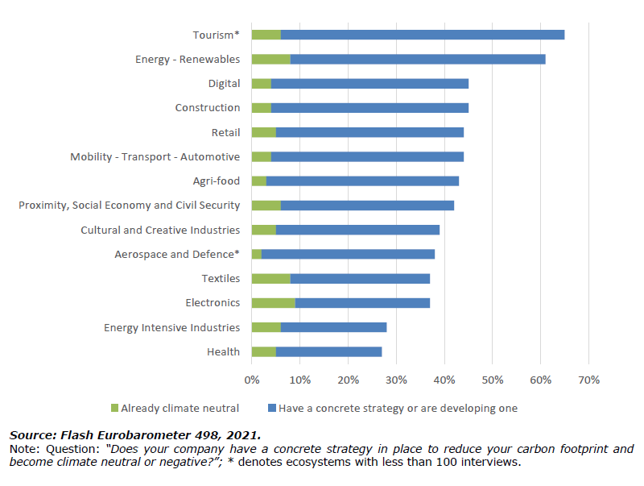

Flash Eurobarometer 498 is a survey conducted by the European Commission to assess the perceptions and attitudes of European small and medium-sized enterprises (SMEs) towards green markets and resource efficiency. From the interviews of 14,215 SMEs and large companies, important information and data have emerged, allowing for a better understanding of the European scenario. The overwhelming majority of SMEs polled are taking steps to become more resource efficient.

In particular, 89% of SMEs are adopting at least one of the survey's recommended activities, while only 9% are not. The percentage of SMEs in the EU that are not making any efforts to be more resource efficient has decreased from 11% to 9%, which is a minor but substantial change from 2017.

Minimising waste (64%) and reducing energy use (61%) are the most common resource efficiency measures used by SMEs. On the other side, only 19% uses renewable energy, 24% sells residues and waste to another company and 33% is switching to greener suppliers of material, confirming the need for the creation of new green synergies within SMEs.

Figure 2: What actions is your company undertaking to be more resource efficient? (% EU27)
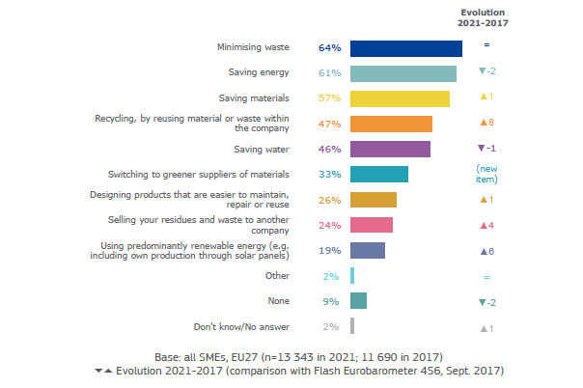
Source: Flash Eurobarometer 498 – SMEs, green markets and resource efficiency, 2022

The majority (83%) of SMEs that are already taking resource efficiency measures intend to take additional measures over the next two years. The most frequent resource efficiency measures planned for the next two years are energy conservation (58%), waste reduction (55%) and material conservation (53%). Yet, real investments in resource efficiency are still insufficient; in the last two years, 35% of the SMEs examined spent 1% or more of their annual turnover in this field.

Figure 3: Over the past two years, how much have you invested on average per year to be more resource efficient? (% by country, EU27)
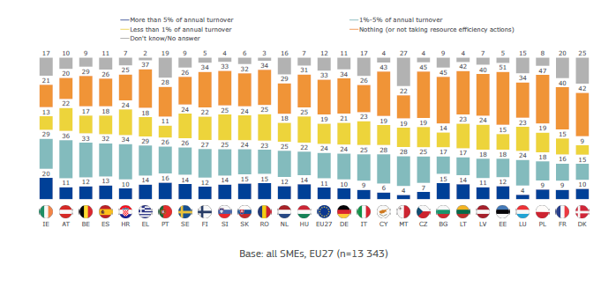
Source: Flash Eurobarometer 498 – SMEs, green markets and resource efficiency , 2022

About 72% of SMEs have not yet established a specific plan to reduce their carbon footprint and achieve climate neutrality or negativity. However, about one quarter of these SMEs are intending to define such a plan. On the other hand, one out of five SMEs has already implemented a concrete strategy to lower their carbon footprint and 4% have already attained climate neutrality. The most common actions taken by SMEs with a carbon reduction strategy are typically reducing carbon emissions within their SME (53%) and adopting or purchasing new technological solutions (49%).

Legislators at the national and European levels must use their influence to accelerate this transition as the need for businesses to switch to more ecologically friendly business models becomes critical. The fact that large corporations have been the main focus of such laws in recent decades, while SMEs have gotten less attention, particularly when it comes to the reduction of their emissions, represents a significant bottleneck for such a policy-based solution. There is still a substantial difference between the quantity of policies targeting SMEs and the capacity to optimise such policies.

Need for training for a sustainable development

Needs assessment

The approach used in the literature to accelerate the green transition of SMEs is often based on identifying drivers and barriers. This approach involves creating a comprehensive list of drivers that motivate SMEs to reduce their emissions, as well as the barriers that prevent them from doing so. Blundel and Hampton offer a detailed chart that presents the most commonly recognized barriers and drivers for SMEs, categorized by their internal and external origin.

Table 1: Common barriers and drivers for the green transition of SMEs

Primary focus | Common Barriers | Common drivers
INTERNAL/INTRA  ORGANIZATIONAL LEVEL | - Lack of awareness  - Lack of specialist knowledge/technical skills  - Limitations in absorptive capacity/organisational learning  - Competing priorities/lack of time  - Resource constraints  - Access to capital  - Short term tenancy agreements  - Lack of strategic alignment | - Cost saving  - Risk mitigation  - Pro-environmental values  - Reputation and image  - Staff morale
EXTERNAL/INTRA  ORGANIZATIONAL LEVEL | - Lack of trusted brokers/intermediaries  - Information deficit regarding opportunities  - Principal-agent/split-incentive problem | - Compliance  - Competitive advantage  - New market opportunities  - Corporate reputation  - Public subsidy

Although SMEs have made significant strides in their sustainability transition, it is worth noting that certain characteristics of SMEs present challenges for their sustainability journey. With limited human resources, including expertise and skills, SMEs may lack knowledge of opportunities, environmental regulations, and support options. Since SMEs often operate in niche markets, they must create their own transition paths that are specific to their niche and cannot rely entirely on established best practices from other markets. Doubts about the feasibility of adopting sustainable technologies and policy environment uncertainty can lead SMEs to under-invest in sustainability. Moreover, financing the green economy is generally capital-intensive and/or risky, which makes the sustainability transition of SMEs more complex.

In particular, SMEs face various challenges when implementing resource efficiency measures as proved by the Flash Eurobarometer 498 survey (2021). The primary obstacle reported by 34% of respondents is the intricate administrative or legal procedures. The second most significant hurdle, cited by 24% of SMEs, is the expense of environmental initiatives. Additionally, in contrast to the 2017 survey results, a higher percentage of SMEs (24%, up by 9 percentage points) now encounter difficulties due to a shortage of necessary materials, parts, products, or services.

Figure 5: Challenges to the adoption or resource efficiency activities, 2021
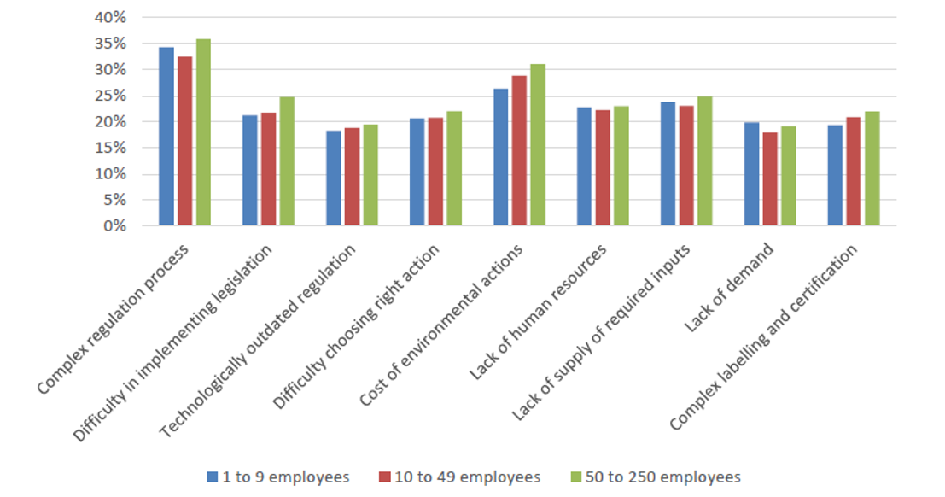
Source: European Commission, Flash Eurobarometer 498: SMEs, green markets and resource efficiency, 2021

Access to finance is frequently cited as a key obstacle for SMEs, although various solutions are currently available in the market (mainly loans and bank overdraft facilities) and through the public sector at the EU and Member State levels (such as the 'Innovate to Transform' platform and the Recovery and Resilience Facility (RRF)).

This factor is confirmed by the results of the Flash Eurobarometer survey (2022) on “SMEs, green markets and resource efficiency”. Grants and subsidies represent the most important factor that could help SMEs to become more resource efficient as well as financial incentives represent the major need for expanding their green offer. Overall, SMEs have recognized several factors that could help them to move towards the green transition, as summed up in the following tables.

Table 2: Factors that, according to EU SMEs, would help them to be more resource efficient

 | SMEs’ %
Grants or subsidies | 36
Better cooperation between companies across sector so to develop  new processes to reuse waste and by-products | 26
Consultancy to improve resource efficiency in the company | 25

Table 3: Factors that, according to EU SMEs, would help them to expand their green offer

 | SMEs’ %
Financial incentives for developing products, services or new processes | 43
Assistance with identifying markets and customers | 27
Technical support and consultancy for developing products, services or new processes | 28

Another important aspect to be considered is the digitalization, which not only offers potential co-benefits for the sustainability transition of SMEs, but it also enhances their crisis resilience. In the midst of the ongoing COVID-19 pandemic, SMEs in the digital sector only saw a decrease in value added of 0.5%, while other SMEs experienced an 8% decrease in value added in 2020. Improved crisis resilience and faster recovery strengthen the ability of SMEs to respond to investment needs for the sustainability transition. Here is a list of the digital solutions perceived by SMEs as more useful to reduce their environmental footprint.

Figure 4: Digital technologies reducing the environmental footprint according to EU SMEs
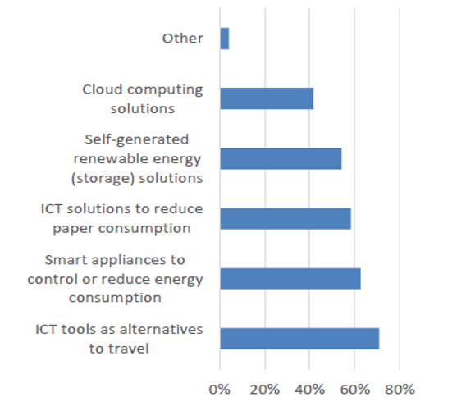
Source: Survey of SMEs Associations, European Commission, Annual report on European SMEs 2020/2021

Support system

SMEs that take resource efficiency actions use a combination of internal and external resources to achieve their goals. Among these SMEs, 64% rely on their own financial resources, and 54% depend on their internal technical expertise. In contrast, 24% of SMEs rely on external support to implement resource efficiency measures.

Among SMEs relying on external support, 36% receive public funding such as grants, guarantees, or loans. This represents an increase of 11 percentage points from the 2017 survey results. In comparison, 28% of SMEs receive private funding from sources such as banks, investment companies, or venture capital funds.

When it comes to non-financial assistance, 39% of SMEs relying on external support receive advice or other types of non-financial assistance from private consulting and audit companies. Supply chain partners provide similar support to 30% of SMEs, while business associations and clusters support 29% of them. Just under a quarter (23%) of SMEs receive advice or other non-financial assistance from public administration.

SMEs can take advantage of various tools provided by the EU to support their pathway towards the transition:

- The Enterprise Europe Network, which provides tailored advisory services and technical assistance to SMEs, with the addition of Sustainability Advisors as of 2022. European Commission provide SMEs with specific expertise and advise through their Sustainability Advisors, who will tailor their advice to adapt SMEs future-proof sustainable businesses.
- The European Resource Efficiency Knowledge Centre, which offers cluster collaboration and knowledge transfer.
- The European Circular Economy Stakeholder Platform brings together stakeholders active in the broad field of the circular economy in Europe. The section of the Platform dedicated to the finance of Circular Economy can help SMEs and entrepreneurs in the search for funding programmes and opportunities, such as the European Structural and Investment Funds, Horizon 2020, the LIFE programme and SMP.

Single Market Programme (SMP) is the EU’s funding initiative to support the single market’s development and assure Europe’s recovery from the COVID-19 epidemic. It offers an integrated package to assist and reinforce the single market’s governance with €4.2 billion over the years 2021–2027. One of the six objectives of the SMP is Strengthening the competitiveness and sustainability of small and medium-sized enterprises. The main aim is to enhance their competitiveness and sustainability, including in the tourism sector. In particular, it aims to facilitate access to markets, promote entrepreneurship, the acquisition of entrepreneurial skills and the modernisation of the industry and address global and societal challenges.

The LIFE programme is the funding instrument for the environment and climate action with a budget of €5.4 billion for the current funding period 2021-2027. LIFE Programme offers support to four sub-programmes 1. Nature and biodiversity 2. Circular economy and quality of life 3. Climate change mitigation and adaptation 4. Clean energy transition.

Another initiative part of the support system at EU level is the European Innovation Council (EIC), which has been created under the EU Horizon Europe funding programme. With a €10.1 billion budget and several funding opportunities, the EIC supports game-changing technologies at every level of development, from early-stage research to proof-of-concept, technology transfer, and start-up finance and scale-up.

Additionally, the SME policy windows of InvestEU provides access to and availability of finance primarily for SMEs, including innovators, SMEs in cultural and creative sectors, and small mid-cap companies. The Access to Finance Portal held SMEs and entrepreneur looking for debt or equity finance to search for financial intermediaries working with InvestEU (see also the InvestEU advisory Hub)

Along access to finance, one of the greatest obstacles to SMEs establishing greater resource efficiency is a lack of competencies. The Erasmus+ programme can fill this gap supporting SMEs in acquiring new skills and competences necessary for the transition. In addition to the Learning Mobility of the staff or the Cooperation Partnership projects like Green Synergy, the Knowledge Alliances and Sector Skills Alliances under Erasmus+ can significantly assist SMEs in resource efficiency. The Knowledge Alliances seek to improve Europe's potential for innovation and to encourage it in higher learning, business, and the larger socioeconomic environment.

Existing training offer

Studies have shown that education and training are needed for SMEs to help them overcome the barriers to green transition. A recommendation on learning for the green transition and sustainable development was approved by the Council of the European Union (EU) in June 2022. How sustainability may be included into all facets of education and training is outlined in this policy statement. Member States are urged to:

- Create environments that facilitate learning about sustainability across all aspects of an educational institution’s operations and allow for practical, multidisciplinary, and context-relevant instruction;

- Involve the research and innovation community, local governments, youth organisations, and faculty and staff in learning for sustainability;

- Give policies and programmes for education and training a priority that emphasise learning for the green transition and sustainable development;

- Offer chances for all students to learn about the climate problem and sustainability in both formal and informal settings, such as schools and higher education (such as, extra-curricular activities, youth work);

- Assist educators in gaining the information and skills necessary to educate about the climate issue and sustainability, including how to cope with eco-anxiety among their students.

- Mobilise national and EU money to invest in green and sustainable equipment, resources, and infrastructure.

The European Sustainability Competence Framework – the Green Comp – developed by the European Commission represents a useful tool that can help trainers and SMEs to identify learning outcomes and evaluate their sustainability competences to adopt green practices and apply the transition.

Some competences of the Framework are particularly relevant for SMEs and should be taken into consideration for the design of tailored training programmes:

Systems Thinking Competence – Working within a green network and establishing synergies between different actors is fundamental to guarantee a greener supply chain and move towards the transition. Improving this competence will help SMEs to approach a sustainability problem from all sides, to consider time, space and context in order to understand how elements interact within and between systems.

Problem Framing Competence – In the planning and managing phase, SMEs should be able to formulate current or potential challenges as a sustainability problem in terms of difficulty, people involved, time and geographical scope, in order to identify suitable approaches to anticipating and preventing problems.

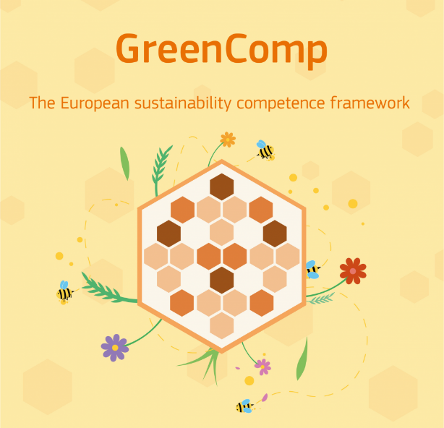
Futures Literacy – SMEs are asked to create new visions, visions to fight climate change. This is why it is important to improve their Futures Literacy, their ability to envision alternative sustainable futures by imagining and developing alternative scenarios and identifying the steps needed to achieve them.

Adaptability – Due to the current economic scenarios there is a pressing need for SMEs to manage transitions and challenges in complex sustainability situations and make decisions related to the future in the face of uncertainty, ambiguity and risk.

Political Agency competence – Improving this competence will help SMEs to navigate the political system, identify political responsibility and accountability for unsustainable behaviours.

Collective Action – SMEs are key actors for the success of the green transition, which engages all sectors of society; for this reason, SMEs should know how to act for change in collaboration with others, within the members of their team and within their communities, with the suppliers and the customers, with local, national or international stakeholders and policy makers.

Individual Initiative – SMEs will effetely contribute to the green transition only if entrepreneurs and their teams will be able to identify their own potential for sustainability and to actively contribute to improving prospects.

Conclusions

The growing concern for the environment and the need to transition towards sustainable development is increasingly affecting the way businesses operate. Small and medium-sized enterprises and entrepreneurs have a vital role to play in achieving sustainable development goals. However, many of them lack the knowledge, resources, and skills necessary to adopt sustainable practices, which makes training and education essential. The available literature shows that there are still significant challenges to overcome, such as the lack of awareness, funding, and regulation. As proved by data collected in this report, enabling and empowering SMEs for the creation of new green synergies is fundamental since:

- Only 19% of SMEs (add source) uses renewable energy, 24% sells residues and waste to another company and only 33% is switching to greener suppliers of material.

- SMEs recognize that better cooperation between companies across sector to develop new processes to reuse waste and by-products can significantly help them become resource efficient

- One of the concrete barriers to green transition within SMEs is the lack of trusted brokers and intermediaries

Other important aspects to be tackled in future training offer tailored to SMEs are:

- Create awareness and offer solutions to the information deficit regarding opportunities, in particular at EU level. Access to finance is frequently cited as a key obstacle for SMEs, although various solutions are currently available in the market.

- Provide assistance for identifying markets and customers and technical support/consultancy for developing products, services or new processes.

- Equip SMEs with best practices that are currently lacking. SMEs often operate in niche markets; they must create their own transition paths that are specific to their niche so cannot rely entirely on established best practices from other markets.

- Improve digital literacy and empowering SMEs with the use of the following digital tools:

    - Cloud Computing Solutions
    - Self-generated renewable energy (storage) solutions
    - ICT solutions to reduce paper consumptions
    - Smart appliances to control or reduce energy consumption
    - ICT tools as alternative to travel

Therefore, policymakers and institutions need to promote and incentivize the adoption of sustainable practices by SMEs and entrepreneurs. Also, there is a need for tailor-made and accessible training programmes for SMEs and entrepreneurs, including vocational education and training and higher education institutions.

The need for training in sustainable business development for SMEs and entrepreneurs is becoming increasingly important as global consumption continues to rise and the negative impacts of resource extraction and waste generation become more apparent. The Circular Economy Action Plan and the European Green Deal provide a framework for this transition, but the direct impact on SMEs is currently limited, with most policies and actions being sector-specific. However, as more sectors and enterprises are included in these policies, SMEs will become increasingly affected. It is crucial for SMEs to adopt circular economy principles and sustainable practices in order to remain competitive, reduce costs, and mitigate risks associated with resource scarcity and climate change. Training and support programmes, such as the Circular Economy Finance Support Platform and the Enterprise Europe Network, can play a key role in facilitating this transition and ensuring that SMEs are not left behind.

In conclusion, it is evident that sustainable business development is increasingly becoming a top priority for SMEs and entrepreneurs. There is a growing need for these businesses to transition towards sustainable practices in order to remain competitive and meet the demands of environmentally conscious consumers. However, the lack of knowledge and resources is a major obstacle for many SMEs, making it difficult for them to implement sustainable practices effectively. This highlights the need for education and training programmes that are tailored to the specific needs of SMEs and entrepreneurs. Projections indicate that the demand for training in sustainable business practices will continue to grow as more businesses recognize the importance of sustainability in achieving long-term success. It is therefore essential that governments and organisations continue to invest in training programmes that are accessible and affordable for SMEs and entrepreneurs.

The Green Comp framework offers a promising approach to provide high quality training and education on sustainable practices for SMEs and entrepreneurs. The implementation of such frameworks and synergies among different stakeholders, including public and private institutions, civil society, and businesses, could contribute significantly to promoting sustainable development among SMEs and entrepreneurs. Therefore, it is recommended that policymakers, institutions, and businesses take a proactive approach towards sustainable development and work together to promote education and training on sustainable practices, implement incentives and regulations, and foster synergies. In addition, SMEs and entrepreneurs need to adopt a proactive behaviour to incorporate sustainable practices into their operations and seek opportunities for education and training on sustainable practices.

Bibliography

BIANCHI Guia; PISIOTIS Ulrike; CABRERA GIRALDEZ Marcelino - JRC Publications Repository, GreenComp The European sustainability competence framework, 2022

European Commission, European Innovation Council and SMEs Executive Agency (EISMEA), https://eismea.ec.europa.eu/programmes/single-market-programme/support-smes_en

European Commission, Internal Market, Industry, Entrepreneurship and SMEs - Small Business Act - Database of good practices, https://ec.europa.eu/growth/tools-databases/sme-best-practices

European Commission, COMMUNICATION FROM THE COMMISSION TO THE EUROPEAN PARLIAMENT, THE COUNCIL, THE EUROPEAN ECONOMIC AND SOCIAL COMMITTEE AND THE COMMITTEE OF THE REGIONS - An SME Strategy for a sustainable and digital Europe, 2020, https://eur-lex.europa.eu/legal-content

European Commission, Internal Market, Industry, Entrepreneurship and SMEs - Entrepreneurship and small and medium-sized enterprises (SMEs), https://single-market-economy.ec.europa.eu/smes_en

European Parliament, Europe’s approach to implementing the Sustainable Development Goal: good practices and the way forward, 2019

Enterprise Europe Network, Sustainability. Helping SMEs in their transition to more sustainable business models, https://een.ec.europa.eu/about-enterprise-europe-network/advice-support/sustainability

European Commission, Environment – Green Business, https://green-business.ec.europa.eu/index_en

European Commission, SME Performance Review Annual Report 2021/2022, https://single-market-economy.ec.europa.eu/smes/sme-strategy/sme-performance-review_en

European Training Foundation, Skills for the green transition, https://www.etf.europa.eu/en/what-we-do/skills-green-transition

European Commission, Circular Economy Action Plan, https://eur-lex.europa.eu/legal-content

European Commission, A European Green Deal, https://commission.europa.eu/strategy-and-policy/priorities-2019-2024/european-green-deal_en

European Commission, JRC Technical Report – Monitoring SMEs’ performance in Europe, 2021

European Commission, Flash Eurobarometer 498 – SMEs, green markets and resource efficiency (Report and Summary), 2022

European Commission, Guidebook Series – How to support SME Policy from Structural Founds. Improving Resource Efficiency in SMEs

